Create a Alarm to monitored the CPU utilization of instance
Create one alarm and click on the view alarm + sign
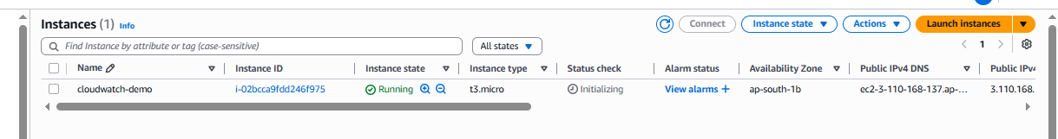
Once we create instance please enable the details monitoring
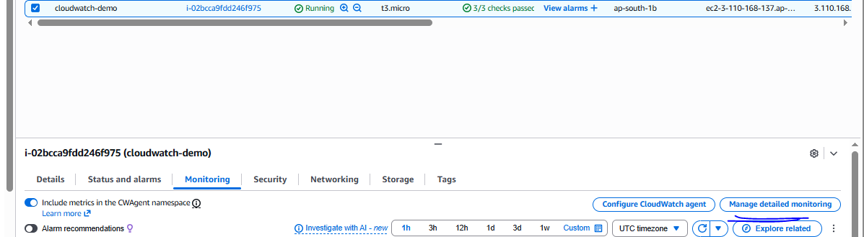
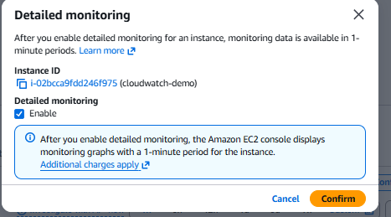
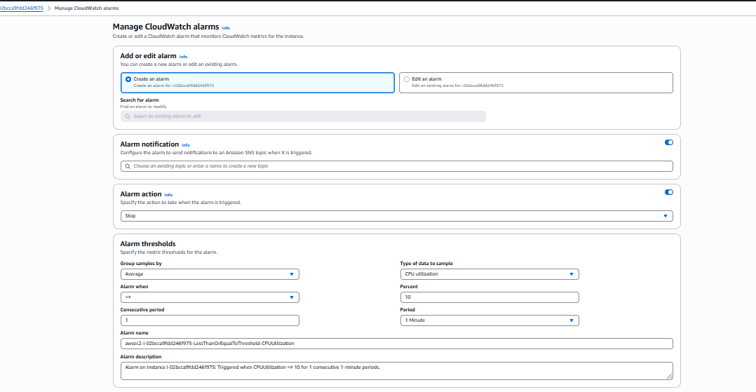

And click on the create button
Alarm has been created
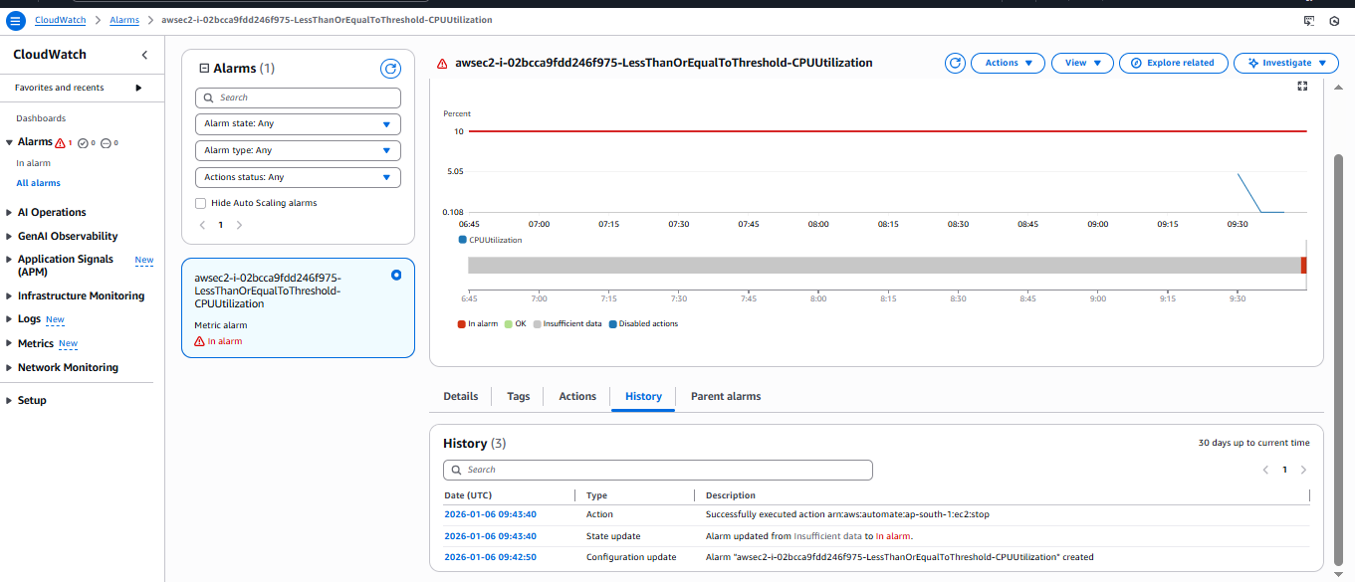

Instance stopped
